ITM Skills University – B.Tech
DBMS Assignment 1 – Core SQL DDL & DML
College Database

Student Name | Sasanka Sekhar Kundu
Subject | Database Management System
Database | PostgreSQL – college_assignment_1

1. Assignment Objective
The objective of this assignment is to practice the core SQL commands used in Data Definition Language (DDL) and Data Manipulation Language (DML). A CollegeStudents table is created and then populated, queried, updated and modified using CREATE, INSERT, WHERE, UPDATE, DELETE and the MAX() aggregate function.

2. Table Structure
Column | Data Type | Description
StudentID | INT | Unique identification number for each student
StudentName | VARCHAR(100) | Name of the student
Department | VARCHAR(100) | Department in which the student is enrolled
Age | INT | Age of the student
Marks | INT | Marks obtained by the student

3. Question 1 – CREATE TABLE
Create a table named CollegeStudents with the required columns.
CREATE TABLE CollegeStudents (
StudentID INT PRIMARY KEY,
StudentName VARCHAR(100) NOT NULL,
Department VARCHAR(100) NOT NULL,
Age INT NOT NULL,
Marks INT NOT NULL
);
SCREENSHOT 1 – CREATE TABLE SUCCESS

4. Question 2 – INSERT Rahul
Insert the first student record.
INSERT INTO CollegeStudents (
StudentID,
StudentName,
Department,
Age,
Marks
)
VALUES (
101,
'Rahul',
'Computer Science',
19,
85
);

5. Question 3 – INSERT Three More Students
Insert the remaining three student records.
INSERT INTO CollegeStudents (
StudentID,
StudentName,
Department,
Age,
Marks
)
VALUES
(102, 'Priya', 'Electronics', 20, 78),
(103, 'Aman', 'Mechanical', 21, 35),
(104, 'Sneha', 'Information Technology', 19, 92);
SCREENSHOT 2 – INSERT SUCCESS.

6. Question 4 – WHERE: Computer Science Students
SELECT *
FROM CollegeStudents
WHERE Department = 'Computer Science';
Expected result: Rahul is displayed because his initial department is Computer Science.
SCREENSHOT 3 – WHERE QUERY RESULT

7. Question 5 – UPDATE Rahul's Marks
UPDATE CollegeStudents
SET Marks = 90
WHERE StudentID = 101;
SELECT *
FROM CollegeStudents
WHERE StudentID = 101;
The marks of Rahul are updated from 85 to 90.

8. Question 6 – UPDATE Rahul's Department
UPDATE CollegeStudents
SET Department = 'Information Technology'
WHERE StudentName = 'Rahul';
SELECT *
FROM CollegeStudents
WHERE StudentName = 'Rahul';
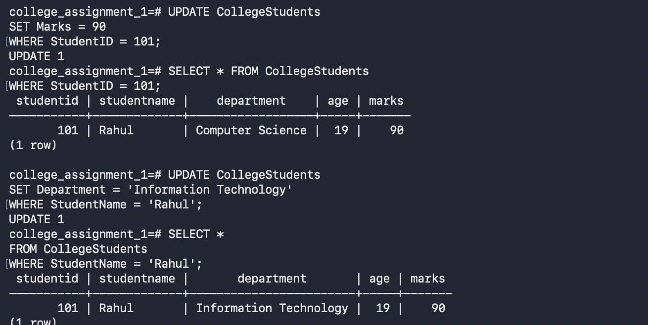SCREENSHOT 4 – UPDATE SUCCESS

9. Question 7 – DELETE StudentID 103
DELETE FROM CollegeStudents
WHERE StudentID = 103;
This deletes Aman from the table.

10. Question 8 – DELETE Students with Marks Less Than 40
DELETE FROM CollegeStudents
WHERE Marks < 40;
Because Aman, who had 35 marks, was already deleted in Question 7, this query may return DELETE 0. This is correct for the required execution order.
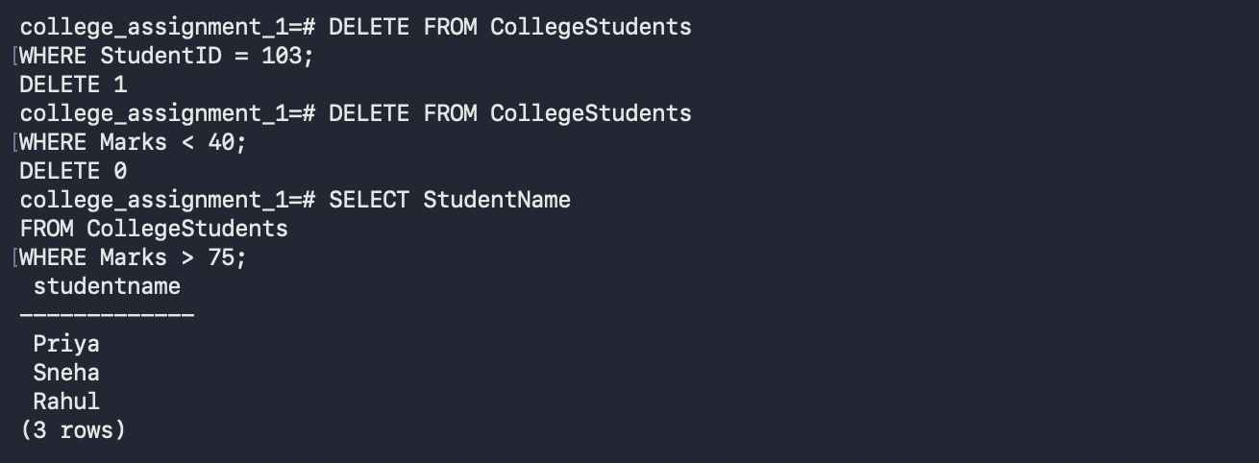SCREENSHOT 5 – DELETE OPERATIONS

11. Question 9 – Students with Marks Greater Than 75
SELECT StudentName
FROM CollegeStudents
WHERE Marks > 75;
Expected final names: Rahul, Priya and Sneha.

12. Question 10 – Aggregate Function: Highest Marks
SELECT MAX(Marks) AS Highest_Marks
FROM CollegeStudents;
Expected result: 92.
SCREENSHOT 6 – FINAL SELECT AND MAX() RESULT

13. Final Table State
StudentID | StudentName | Department | Age | Marks
101 | Rahul | Information Technology | 19 | 90
102 | Priya | Electronics | 20 | 78
104 | Sneha | Information Technology | 19 | 92

14. Complete SQL Code
-- Question 1
CREATE TABLE CollegeStudents (
StudentID INT PRIMARY KEY,
StudentName VARCHAR(100) NOT NULL,
Department VARCHAR(100) NOT NULL,
Age INT NOT NULL,
Marks INT NOT NULL
);
-- Question 2
INSERT INTO CollegeStudents
VALUES (101, 'Rahul', 'Computer Science', 19, 85);
-- Question 3
INSERT INTO CollegeStudents
VALUES
(102, 'Priya', 'Electronics', 20, 78),
(103, 'Aman', 'Mechanical', 21, 35),
(104, 'Sneha', 'Information Technology', 19, 92);
-- Question 4
SELECT * FROM CollegeStudents
WHERE Department = 'Computer Science';
-- Question 5
UPDATE CollegeStudents
SET Marks = 90
WHERE StudentID = 101;
-- Question 6
UPDATE CollegeStudents
SET Department = 'Information Technology'
WHERE StudentName = 'Rahul';
-- Question 7
DELETE FROM CollegeStudents
WHERE StudentID = 103;
-- Question 8
DELETE FROM CollegeStudents
WHERE Marks < 40;
-- Question 9
SELECT StudentName
FROM CollegeStudents
WHERE Marks > 75;
-- Question 10
SELECT MAX(Marks) AS Highest_Marks
FROM CollegeStudents;

15. Conclusion
This assignment demonstrates the complete basic SQL workflow. The CollegeStudents table was created using CREATE TABLE, records were added using INSERT, specific records were displayed using WHERE, existing values were modified using UPDATE, unwanted records were removed using DELETE, and the highest marks were identified using the MAX() aggregate function. The final table contains Rahul, Priya and Sneha, while Aman was removed according to the assignment requirements.

